**Air University**

(Multan Campus)

|  |
| --- |
| Department of Computer Sciences |
| Software Engineering |
| **Mehran Qadir Roll#142063** |
|  |
| **BSCS-VII**  **GIT & GITHUB ASSIGNMENT SOLUTION**  **Exercise 0:**  Create a Repository with the same name : |

Exercise 1:

Creating a Local Repository:

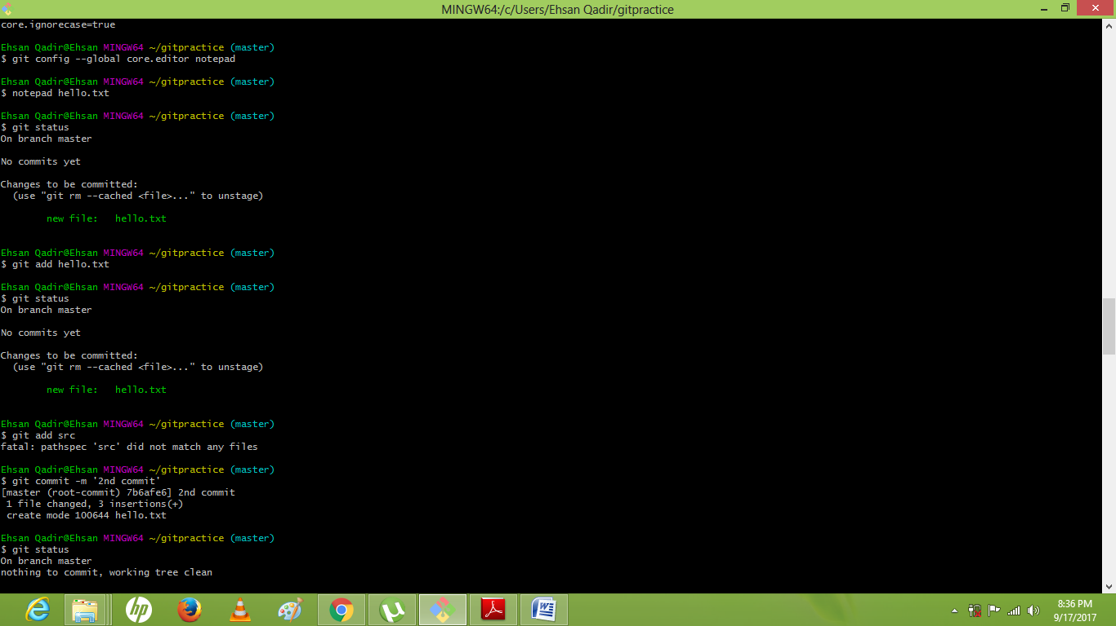

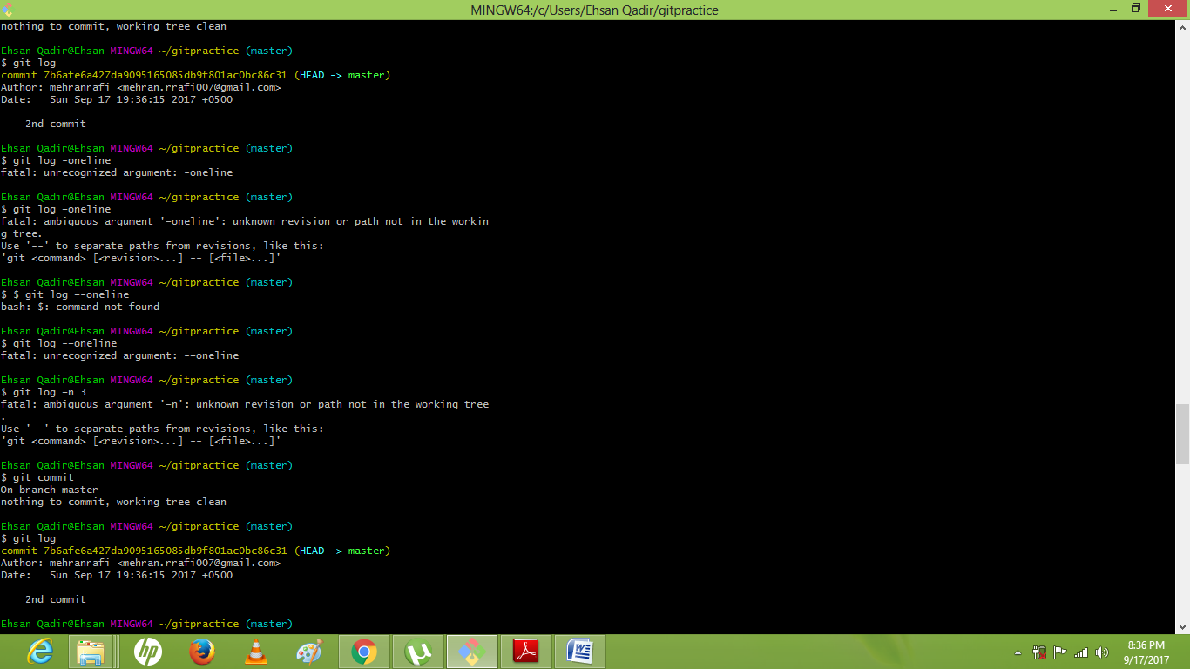

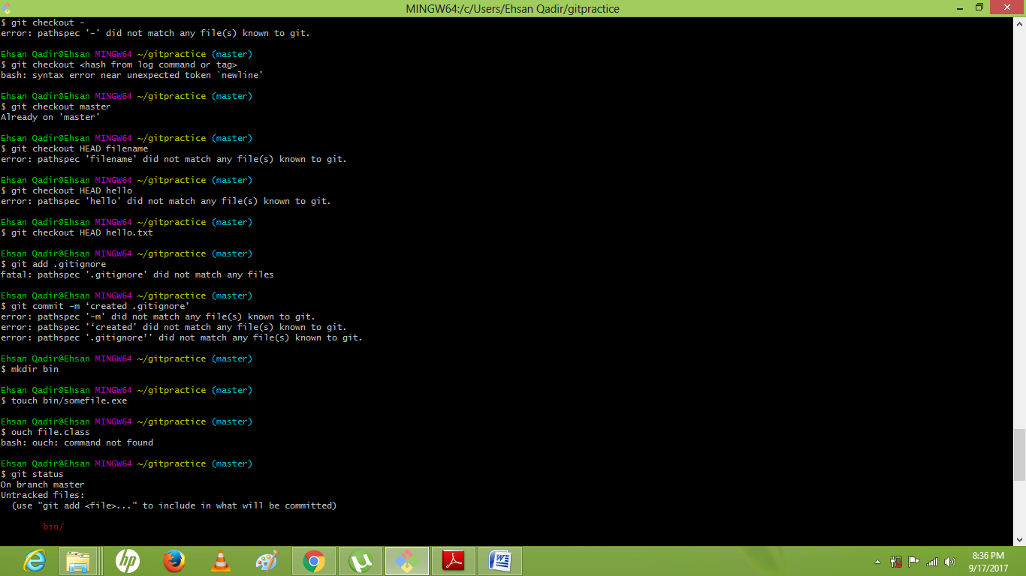

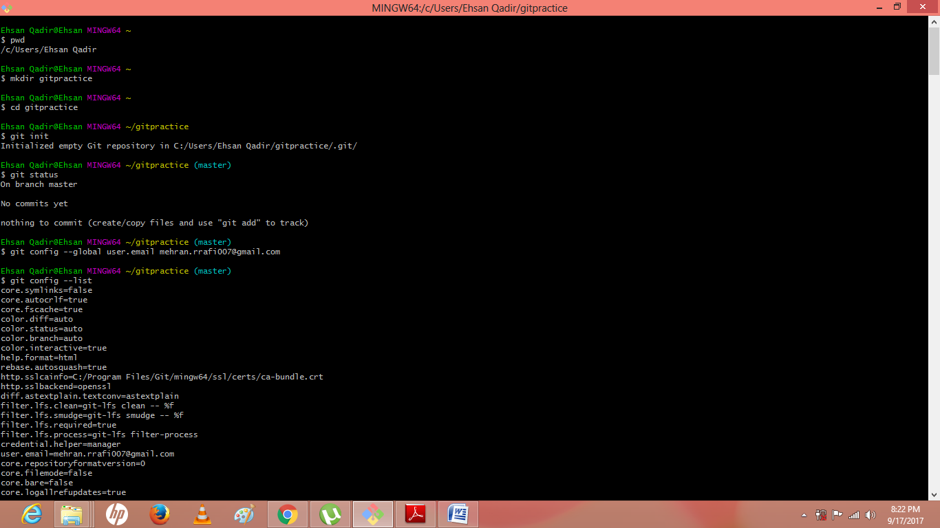

Exercise 2:

Cloning an existing repository:

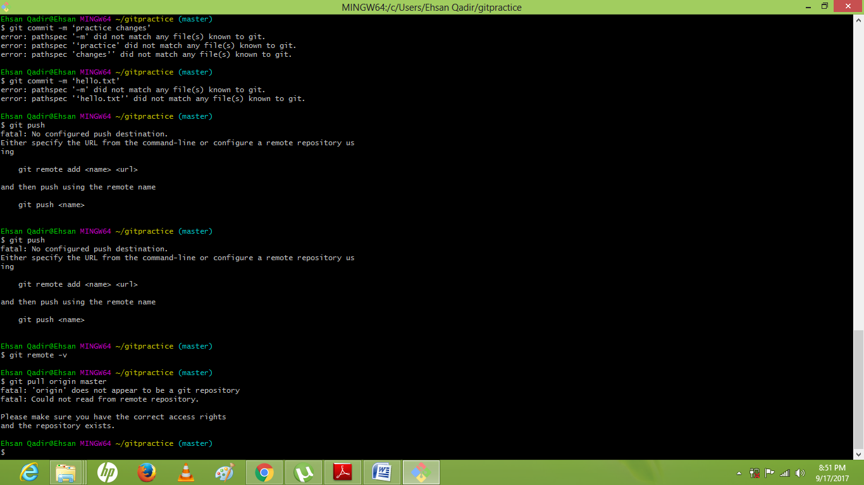

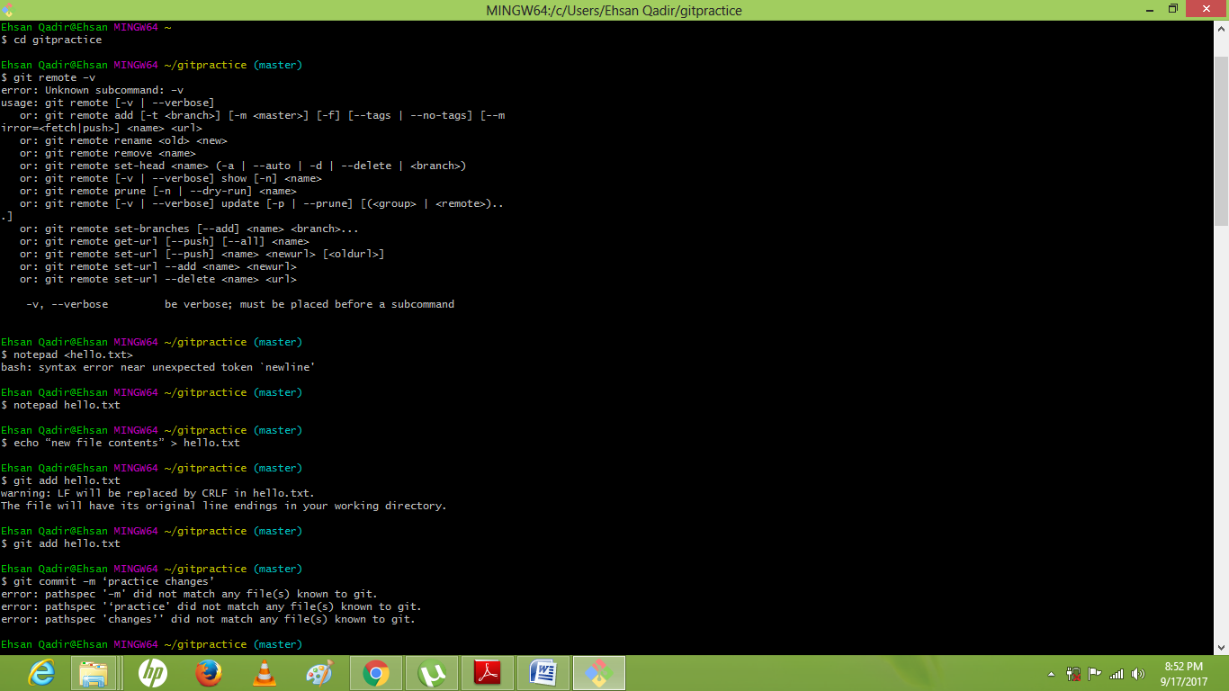

Exercise 3:

Contributing to an existing Git-Hub project:

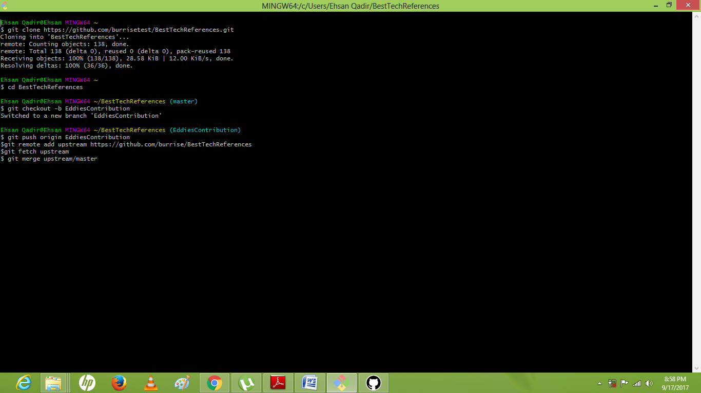

Meharnrafi@DESKTOP-VGOP2LL MINGW64 ~/calculator (master)

$ git clone https://github.com/burrisetest/BestTechReferences.git

Cloning into 'BestTechReferences'...

remote: Counting objects: 138, done.

remote: Total 138 (delta 0), reused 0 (delta 0), pack-reused 138

Receiving objects: 100% (138/138), 28.58 KiB | 164.00 KiB/s, done.

Resolving deltas: 100% (36/36), done.

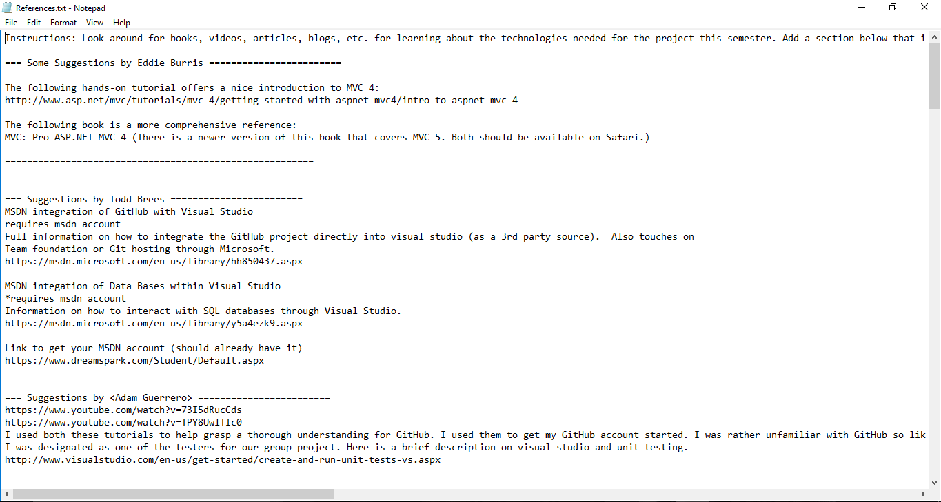

Exercise 4:

Adding a Remote:

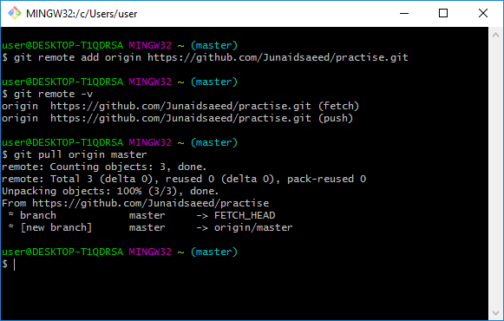

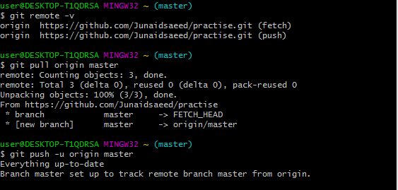

Exercise 5:

Branching and Merging:

Ehsan Qadir@Ehsan MINGW64 ~

$ mkdir website

Ehsan Qadir@Ehsan MINGW64 ~

$ cd website

Ehsan Qadir@Ehsan MINGW64 ~/website

$ git init

Initialized empty Git repository in C:/Users/Ehsan Qadir/website/.git/

Ehsan Qadir@Ehsan MINGW64 ~/website (master)

$ notepad index.html

Ehsan Qadir@Ehsan MINGW64 ~/website (master)

$ git add index.html

Ehsan Qadir@Ehsan MINGW64 ~/website (master)

$ git commit -m 'initial checkin'

[master (root-commit) 850330d] initial checkin

1 file changed, 10 insertions(+)

create mode 100644 index.html

Ehsan Qadir@Ehsan MINGW64 ~/website (master)

$ git branch

* master

Ehsan Qadir@Ehsan MINGW64 ~/website (master)

$ git branch contactinfo

Ehsan Qadir@Ehsan MINGW64 ~/website (master)

$ git branch

contactinfo

* master

Ehsan Qadir@Ehsan MINGW64 ~/website (master)

$ git checkout contactinfo

Switched to branch 'contactinfo'

Ehsan Qadir@Ehsan MINGW64 ~/website (contactinfo)

$ notepad index.html

Ehsan Qadir@Ehsan MINGW64 ~/website (contactinfo)

$ git add index.html

Ehsan Qadir@Ehsan MINGW64 ~/website (contactinfo)

$ git commit –m ‘add phone contact’

error: pathspec '–m' did not match any file(s) known to git.

error: pathspec '‘add' did not match any file(s) known to git.

error: pathspec 'phone' did not match any file(s) known to git.

error: pathspec 'contact’' did not match any file(s) known to git.

Ehsan Qadir@Ehsan MINGW64 ~/website (contactinfo)

$ git commit -m 'add phone contact'

[contactinfo e11b5ef] add phone contact

1 file changed, 2 insertions(+)

Ehsan Qadir@Ehsan MINGW64 ~/website (contactinfo)

$ git checkout master

Switched to branch 'master'

Ehsan Qadir@Ehsan MINGW64 ~/website (master)

$ cat index.html

<html>

<body>

<h1>We are open:</h1>

<ol>

<li>Monday</li>

<li>Wednesday</li>

<li>Friday</li>

</ol>

</body>

</html>

Ehsan Qadir@Ehsan MINGW64 ~/website (master)

$ $ cat index.html

bash: $: command not found

Ehsan Qadir@Ehsan MINGW64 ~/website (master)

$ git checkout contactinfo

Switched to branch 'contactinfo'

Ehsan Qadir@Ehsan MINGW64 ~/website (contactinfo)

$ notepad index.html

Ehsan Qadir@Ehsan MINGW64 ~/website (contactinfo)

$ notepad index.html

Ehsan Qadir@Ehsan MINGW64 ~/website (contactinfo)

$ git add index.html

Ehsan Qadir@Ehsan MINGW64 ~/website (contactinfo)

$ git commit –m ‘add phone contact’

error: pathspec '–m' did not match any file(s) known to git.

error: pathspec '‘add' did not match any file(s) known to git.

error: pathspec 'phone' did not match any file(s) known to git.

error: pathspec 'contact’' did not match any file(s) known to git.

Ehsan Qadir@Ehsan MINGW64 ~/website (contactinfo)

$ git commit -m 'add phone contact'

[contactinfo 1383955] add phone contact

1 file changed, 1 insertion(+), 1 deletion(-)

Ehsan Qadir@Ehsan MINGW64 ~/website (contactinfo)

$ git checkout master

Switched to branch 'master'

Ehsan Qadir@Ehsan MINGW64 ~/website (master)

$ notepad index.html

Ehsan Qadir@Ehsan MINGW64 ~/website (master)

$ git add index.html

Ehsan Qadir@Ehsan MINGW64 ~/website (master)

$ git commit –m ‘add title’

error: pathspec '–m' did not match any file(s) known to git.

error: pathspec '‘add' did not match any file(s) known to git.

error: pathspec 'title’' did not match any file(s) known to git.

Ehsan Qadir@Ehsan MINGW64 ~/website (master)

$ git commit -m 'add title'

[master c1705a3] add title

1 file changed, 4 insertions(+), 1 deletion(-)

Ehsan Qadir@Ehsan MINGW64 ~/website (master)

$ git branch

contactinfo

* master

Ehsan Qadir@Ehsan MINGW64 ~/website (master)

$ git merge contactinfo

Auto-merging index.html

unix2dos: converting file C:/Users/Ehsan Qadir/website/.git/MERGE_MSG to DOS for mat...

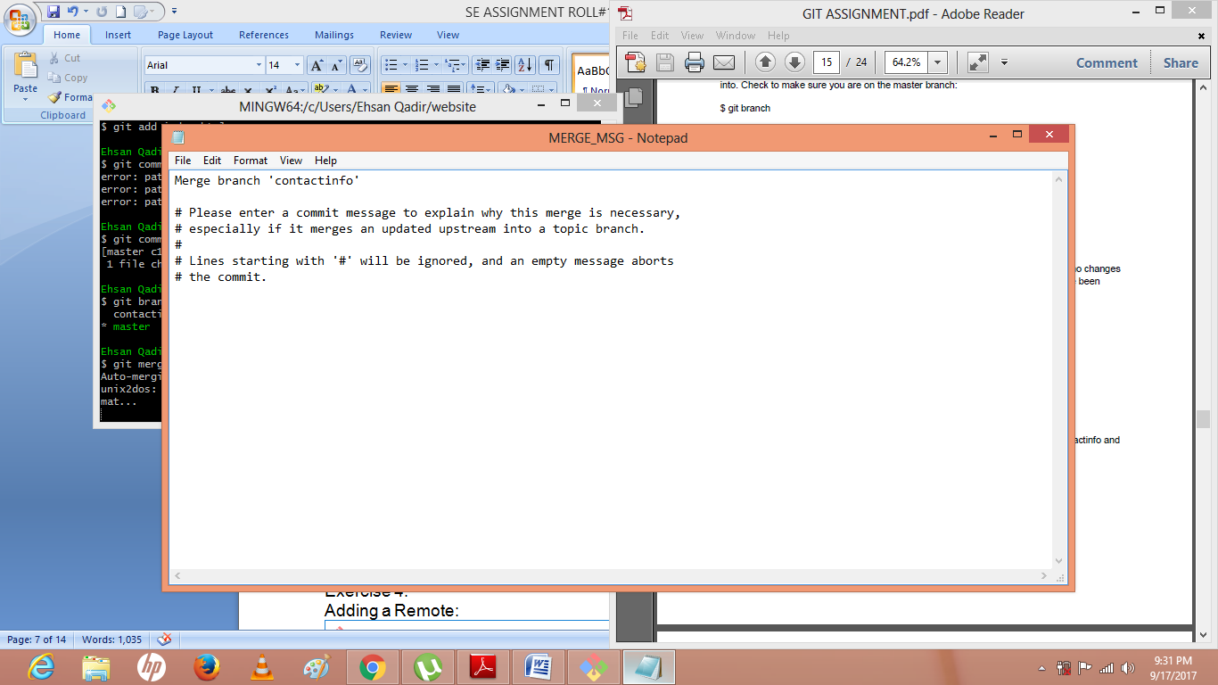

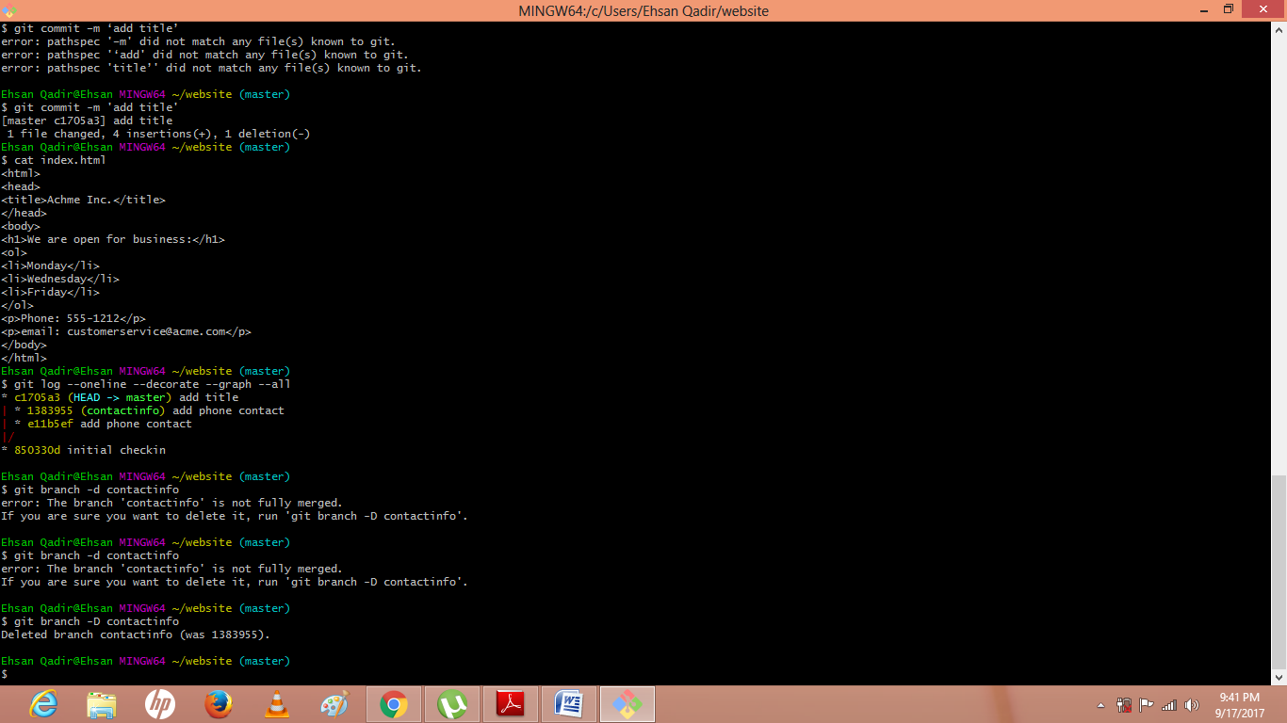

Exercise 5:

Branching and merging with conflicts:

Ehsan Qadir@Ehsan MINGW64 ~

$ mkdir website

Ehsan Qadir@Ehsan MINGW64 ~

$ cd website

Ehsan Qadir@Ehsan MINGW64 ~/website

$ git init

Initialized empty Git repository in C:/Users/Ehsan Qadir/website/.git/

Ehsan Qadir@Ehsan MINGW64 ~/website (master)

$ notepad index.html

Ehsan Qadir@Ehsan MINGW64 ~/website (master)

$ git add index.html

Ehsan Qadir@Ehsan MINGW64 ~/website (master)

$ git commit -m 'initial checkin'

[master (root-commit) 850330d] initial checkin

1 file changed, 10 insertions(+)

create mode 100644 index.html

Ehsan Qadir@Ehsan MINGW64 ~/website (master)

$ git branch

* master

Ehsan Qadir@Ehsan MINGW64 ~/website (master)

$ git branch contactinfo

Ehsan Qadir@Ehsan MINGW64 ~/website (master)

$ git branch

contactinfo

* master

Ehsan Qadir@Ehsan MINGW64 ~/website (master)

$ git checkout contactinfo

Switched to branch 'contactinfo'

Ehsan Qadir@Ehsan MINGW64 ~/website (contactinfo)

$ notepad index.html

Ehsan Qadir@Ehsan MINGW64 ~/website (contactinfo)

$ git add index.html

Ehsan Qadir@Ehsan MINGW64 ~/website (contactinfo)

$ git commit –m ‘add phone contact’

error: pathspec '–m' did not match any file(s) known to git.

error: pathspec '‘add' did not match any file(s) known to git.

error: pathspec 'phone' did not match any file(s) known to git.

error: pathspec 'contact’' did not match any file(s) known to git.

Ehsan Qadir@Ehsan MINGW64 ~/website (contactinfo)

$ git commit -m 'add phone contact'

[contactinfo e11b5ef] add phone contact

1 file changed, 2 insertions(+)

Ehsan Qadir@Ehsan MINGW64 ~/website (contactinfo)

$ git checkout master

Switched to branch 'master'

Ehsan Qadir@Ehsan MINGW64 ~/website (master)

$ cat index.html

<html>

<body>

<h1>We are open:</h1>

<ol>

<li>Monday</li>

<li>Wednesday</li>

<li>Friday</li>

</ol>

</body>

</html>

Ehsan Qadir@Ehsan MINGW64 ~/website (master)

$ $ cat index.html

bash: $: command not found

Ehsan Qadir@Ehsan MINGW64 ~/website (master)

$ git checkout contactinfo

Switched to branch 'contactinfo'

Ehsan Qadir@Ehsan MINGW64 ~/website (contactinfo)

$ notepad index.html

Ehsan Qadir@Ehsan MINGW64 ~/website (contactinfo)

$ notepad index.html

Ehsan Qadir@Ehsan MINGW64 ~/website (contactinfo)

$ git add index.html

Ehsan Qadir@Ehsan MINGW64 ~/website (contactinfo)

$ git commit –m ‘add phone contact’

error: pathspec '–m' did not match any file(s) known to git.

error: pathspec '‘add' did not match any file(s) known to git.

error: pathspec 'phone' did not match any file(s) known to git.

error: pathspec 'contact’' did not match any file(s) known to git.

Ehsan Qadir@Ehsan MINGW64 ~/website (contactinfo)

$ git commit -m 'add phone contact'

[contactinfo 1383955] add phone contact

1 file changed, 1 insertion(+), 1 deletion(-)

Ehsan Qadir@Ehsan MINGW64 ~/website (contactinfo)

$ git checkout master

Switched to branch 'master'

Ehsan Qadir@Ehsan MINGW64 ~/website (master)

$ notepad index.html

Ehsan Qadir@Ehsan MINGW64 ~/website (master)

$ git add index.html

Ehsan Qadir@Ehsan MINGW64 ~/website (master)

$ git commit –m ‘add title’

error: pathspec '–m' did not match any file(s) known to git.

error: pathspec '‘add' did not match any file(s) known to git.

error: pathspec 'title’' did not match any file(s) known to git.

Ehsan Qadir@Ehsan MINGW64 ~/website (master)

$ git commit -m 'add title'

[master c1705a3] add title

1 file changed, 4 insertions(+), 1 deletion(-)

Ehsan Qadir@Ehsan MINGW64 ~/website (master)

$ git branch

contactinfo

* master

Ehsan Qadir@Ehsan MINGW64 ~/website (master)

$ git merge contactinfo

Auto-merging index.html

unix2dos: converting file C:/Users/Ehsan Qadir/website/.git/MERGE_MSG to DOS for mat...



Exercise 6:

Branching and remotes:

user@DESKTOP-T1QDRSA MINGW32 ~ (master)

$ git remote

origin

user@DESKTOP-T1QDRSA MINGW32 ~ (master)

$ git remote -v

origin https://github.com/abdullahqasim/practise.git (fetch)

origin https://github.com/abdullahqasim/practise.git (push)

user@DESKTOP-T1QDRSA MINGW32 ~ (master)

$ git remote add upstream https://github.com/abdullahqasim/practise

user@DESKTOP-T1QDRSA MINGW32 ~ (master)

$ git branch -r

origin/master

user@DESKTOP-T1QDRSA MINGW32 ~ (master)

$ git checkout origin/feature123

error: pathspec 'origin/feature123' did not match any file(s) known to git.

user@DESKTOP-T1QDRSA MINGW32 ~ (master)

$ git branch-r

git: 'branch-r' is not a git command. See 'git --help'.

user@DESKTOP-T1QDRSA MINGW32 ~ (master)

$ git branch --r

origin/master

user@DESKTOP-T1QDRSA MINGW32 ~ (master)

$ is

bash: is: command not found

user@DESKTOP-T1QDRSA MINGW32 ~ (master)

$ Is

bash: Is: command not found

user@DESKTOP-T1QDRSA MINGW32 ~ (master)

$ git checkout origin/feature123

error: pathspec 'origin/feature123' did not match any file(s) known to git.

user@DESKTOP-T1QDRSA MINGW32 ~ (master)

$ Is

bash: Is: command not found

user@DESKTOP-T1QDRSA MINGW32 ~ (master)

$ git checkout master

Already on 'master'

Your branch is up-to-date with 'origin/master'.

user@DESKTOP-T1QDRSA MINGW32 ~ (master)

$ git clone https://github.com/abdullahqasim/practise.git

Cloning into 'practise'...

remote: Counting objects: 3, done.

remote: Total 3 (delta 0), reused 0 (delta 0), pack-reused 0

Unpacking objects: 100% (3/3), done.

user@DESKTOP-T1QDRSA MINGW32 ~ (master)

$ cd practise

user@DESKTOP-T1QDRSA MINGW32 ~/practise (master)

$ git branch -r

origin/HEAD -> origin/master

origin/master

user@DESKTOP-T1QDRSA MINGW32 ~/practise (master)

$ cd

user@DESKTOP-T1QDRSA MINGW32 ~ (master)

$ git clone https://github.com/abdullahqasim/practise.git practisecopy

Cloning into 'practisecopy'...

remote: Counting objects: 3, done.

remote: Total 3 (delta 0), reused 0 (delta 0), pack-reused 0

Unpacking objects: 100% (3/3), done.

user@DESKTOP-T1QDRSA MINGW32 ~ (master)

$ cd practise

user@DESKTOP-T1QDRSA MINGW32 ~/practise (master)

$ git checkout -b fix 123

fatal: '123' is not a commit and a branch 'fix' cannot be created from it

user@DESKTOP-T1QDRSA MINGW32 ~/practise (master)

$ git push

Everything up-to-date

user@DESKTOP-T1QDRSA MINGW32 ~/practise (master)

$ git push origin fix 123

error: src refspec fix does not match any.

error: src refspec 123 does not match any.

error: failed to push some refs to 'https://github.com/abdullahqasim/practise.git'

user@DESKTOP-T1QDRSA MINGW32 ~/practise (master)

$ git push origin practisecopy

error: src refspec practisecopy does not match any.

error: failed to push some refs to 'https://github.com/abdullahqasim/practise.git'

user@DESKTOP-T1QDRSA MINGW32 ~/practise (master)

$ cd /practisecopy

bash: cd: /practisecopy: No such file or directory

user@DESKTOP-T1QDRSA MINGW32 ~/practise (master)

$ git branch -r

origin/HEAD -> origin/master

origin/master

user@DESKTOP-T1QDRSA MINGW32 ~/practise (master)

$ git fetch origin

user@DESKTOP-T1QDRSA MINGW32 ~/practise (master)

$ git branch -r

origin/HEAD -> origin/master

origin/master

user@DESKTOP-T1QDRSA MINGW32 ~/practise (master)

$ git checkout -b fix123 origin/fix123

fatal: 'origin/fix123' is not a commit and a branch 'fix123' cannot be created from it

user@DESKTOP-T1QDRSA MINGW32 ~/practise (master)

$ notepad file.c

git add

$ git

user@DESKTOP-T1QDRSA MINGW32 ~/practise (master)

$ git add

Nothing specified, nothing added.

Maybe you wanted to say 'git add .'?

user@DESKTOP-T1QDRSA MINGW32 ~/practise (master)

$ git commit -m'second developer added a fourth line'

On branch master

Your branch is up-to-date with 'origin/master'.

Untracked files:

file.c

nothing added to commit but untracked files present

user@DESKTOP-T1QDRSA MINGW32 ~/practise (master)

$ git add

Nothing specified, nothing added.

Maybe you wanted to say 'git add .'?

user@DESKTOP-T1QDRSA MINGW32 ~/practise (master)

$ git commit -m'second developer added a fourth line'$git

On branch master

Your branch is up-to-date with 'origin/master'.

Untracked files:

file.c

nothing added to commit but untracked files present

user@DESKTOP-T1QDRSA MINGW32 ~/practise (master)

$ git push

Everything up-to-date

user@DESKTOP-T1QDRSA MINGW32 ~/practise (master)

$ cd /practisecopy

bash: cd: /practisecopy: No such file or directory

user@DESKTOP-T1QDRSA MINGW32 ~/practise (master)

$ git fetch

user@DESKTOP-T1QDRSA MINGW32 ~/practise (master)

$ git log --oneline

df23618 (HEAD -> master, origin/master, origin/HEAD) Initial commit

user@DESKTOP-T1QDRSA MINGW32 ~/practise (master)

$ git log -oneline

fatal: unrecognized argument: -oneline

user@DESKTOP-T1QDRSA MINGW32 ~/practise (master)

$ git remote show origin

* remote origin

Fetch URL: https://github.com/abdullahqasim/practise.git

Push URL: https://github.com/abdullahqasim/ practise.git

HEAD branch: master

Remote branch:

master tracked

Local branch configured for 'git pull':

master merges with remote master

Local ref configured for 'git push':

master pushes to master (up to date)

user@DESKTOP-T1QDRSA MINGW32 ~/practise (master)